a



**PROJECT BASED LEARNING (PBL-3) LAB (CSP391)**

**Project Title**

**Flight Information Display System using the concept of File Management System**

**B.TECH 3rd YEAR**

**SEMESTER: 5th**

**SESSION: 2023-2024**

**Submitted By:**

**Shashi Kant Ojha (2021310608)**

**Tanvi Bhole (2021470191)**

**SECTION:**

**Submitted To**

**Dr. Sandeep Kumar**

**Associate Professor**

**DEPARTMENT OF COMPUTER SCIENCE & ENGINEERING**

**SHARDA SCHOOL OF ENGINEERING & TECHNOLOGY**

**SHARDA UNIVERSITY, GREATER NOIDA**

Table of Contents Page No

Project Title 3

Team / Group Formation: 3

Technologies to be used 3

Software Platform 3

Hardware Platform 3

Problem Statement 3

Literature Survey 4

Project Description 6

Project Modules: Design/Algorithm 6

Implementation Methodology 8

Result & Conclusion 9

Future Scope and further enhancement of the Project 10

Advantages of this Project 10

Outcome 10

References 10

# Project Title

**Flight Information Display System using the concept of File management system**

# Team / Group Formation:

|  |  |  |  |  |
| --- | --- | --- | --- | --- |
| **S. No** | **Student Name** | **Roll Number** | **System ID** | **Role** |
| **1** | **Shashi kant ojha** | **210101450** | **2021310608** | **Implementation** |
| **2** | **Tanvi Bhole** | **210101526** | **2021470191** | **Designing part** |

# Technologies to be used

# Software Platform

Visual studio, Python (3.8) modules, Machine learning concepts (Regression concepts) and IOT based technique.

## Hardware Platform

RAM, Hard Disk, OS, Editor, Browser, proper internet connection.

# Problem Statement

As per technical terms FIDS is generally a software used for displaying flights related information on big screen. It also works as a media platform for entertainment and other services. Also known as Digital Signage Software, such systems not only allow the passengers to find the terminal and their respective gates but also provides real time information regarding departure and arrival of any aircraft. It also provides real time feedback regarding wind direction, speed and various terminologies related to pressure and thrust. As, it is known that timed information of any data helps in providing the real time navigation with constant support and other facilities so in today's generation these types of innovations can create a huge impact by revolutionizing the way of thinking and the way of acting as per situations by implementing the Concepts OF IOT and Machine Learning.

# Literature Survey

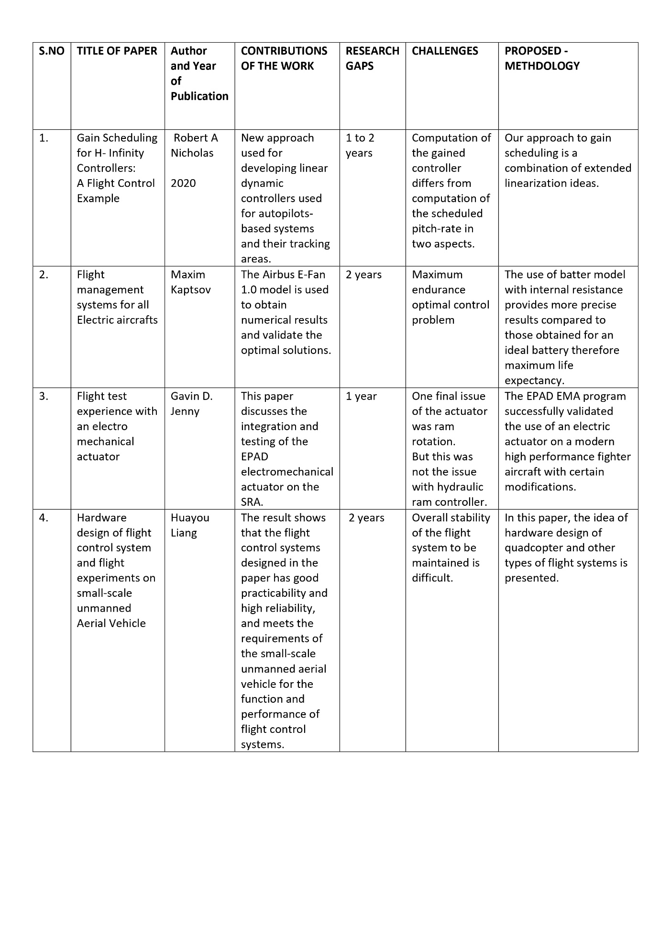

Another notable advancement is the use of artificial intelligence (AI) algorithms in FIDS, which can analyse and predict flight patterns and disruptions, providing more accurate and timely information to passengers. Overall, these advancements in FIDS have greatly improved the efficiency and effectiveness of flight information communication, enhancing the overall passenger experience. In recent years, there have been significant advancements in flight information display systems (FIDS) that have revolutionized the way air travel information is communicated. These digital signs can provide real-time flight updates, gate information, and even weather conditions in a visually engaging format. Additionally, FIDS now integrate with mobile apps and websites, allowing passengers to access flight information conveniently on their smartphones or tablets. This connectivity also enables airlines to push notifications directly to passengers, notifying them of any changes or delays to their flights.

Since most information is presented in a graphical way, it can intuitively be seized by the pilots. Especially in phases of high work-load, the highly pre-processed information and its redundant presentation will significantly contribute to assure pilots situation awareness both in the air and on the ground. We propose an off-axis flight vision display system design with a free-form surface using machine learning to simulate the visual distance variation during take-off and landing training for pilots. This design is realized by ray tracing using ZEMAX software, where we build and optimize a series of initial systems that meet the corresponding optical specifications. A deep neural network is used to train the regression model, which is specifically designed to predict the fitted polynomial model for the free-form surface of the system. Our results demonstrate that the design of a flight visual display system can be transformed into a machine learning problem and further optimized by training and learning with abundant data, providing an avenue to design more powerful and complex imaging optical systems.

We propose an off-axis flight vision display system design with a free-form surface using machine learning to simulate the visual distance variation during take-off and landing training for pilots. This design is realized by ray tracing using ZEMAX software, where we build and optimize a series of initial systems that meet the corresponding optical specifications. A deep neural network is used to train the regression model, which is specifically designed to predict the fitted polynomial model for the free-form surface of the system. Our results demonstrate that the design of a flight visual display system can be transformed into a machine learning problem and further optimized by training and learning with abundant data, providing an avenue to design more powerful and complex imaging optical systems.

We propose an off-axis flight vision display system design with a free-form surface using machine learning to simulate the visual distance variation during take-off and landing training for pilots. This design is realized by ray tracing using ZEMAX software, where we build and optimize a series of initial systems that meet the corresponding optical specifications. A deep neural network is used to train the regression model, which is specifically designed to predict the fitted polynomial model for the free-form surface of the system. Our results demonstrate that the design of a flight visual display system can be transformed into a machine learning problem and further optimized by training and learning with abundant data, providing an avenue to design more powerful and complex imaging optical systems.

While the Navigation System has to provide information about current position, attitudes, and sensor integrity, the databases provide information for terrain, obstacles, airports and navigation aids. Distributed cognition is a useful approach to study the interaction between agents (humans or artefacts) in a system, such as the collaboration involved in air traffic control. When taking a distributed cognition perspective, information processing can be directly observed. This provides the opportunity to explore how information moves through a system, and to identify specific areas where (pervasive) technology can be introduced. However, the analysis involved cannot be simply used “off-the-shelf” and must be tailored to specific scenario. Furthermore, the amount of time spent conducting the analysis is often quite significant. This motivates the need for a software tool to support this kind of analysis; to guide the researcher, and reduce the amount of time spent on analysis. This paper presents a prototype of such a tool.

To restrain the negative effects of bounded disturbances, a nonlinear DTDO is designed. Then, a backstepping technique-based ANC strategy is proposed by utilizing a constructed auxiliary system and a discrete-time tracking differentiator. The boundness of all signals is proven in the closed-loop system under the discrete-time Lyapunov analysis. Finally, the feasibility of the proposed ANC technique is further specified based on numerical simulation results.

To restrain the negative effects of bounded disturbances, a nonlinear DTDO is designed. Then, a backstepping technique-based ANC strategy is proposed by utilizing a constructed auxiliary system and a discrete-time tracking differentiator. The boundness of all signals is proven in the closed-loop system under the discrete-time Lyapunov analysis. Finally, the feasibility of the proposed ANC technique is further specified based on numerical simulation results.

Over the past forty years, the number of fighters aircraft-controlled flight into terrain (CFIT) accidents per flight hour has not improved despite the addition of multiple manual warning systems. The Air Force Research Laboratory (AFRL) has undertaken a program to develop an automatic system that will take over when the pilot can no longer recover the aircraft, perform an automatic recovery and quickly return control to the pilot. It is called the Automatic Ground Collision Avoidance System or Auto GCAS. This system has been successfully demonstrated on a Block 50 F-16 with a digital flight control system as shown in Figure 1 and is transitioning to operational Block 40/50 F-16s. Recent years have marked a significant step forward in the development of all-electric airplanes, some of which have been built and tested recently. This paper proposes an optimal control framework for flight management systems of all-electric aircraft. The optimal control problems of economy mode and maximum endurance will be solved using Portraying’s minimum principle. The economy mode optimization problem corresponds to the minimization of a functional parameterized by a coefficient index that performs a trade-off between the cost of the battery charge and timerelated costs.

# Project Description

As today’s era is based on the concept of deep learning concepts and some beneficial ideas in order to facilitate the usage of user’s and their day-to-day tasks. So, in order to deal with it most of the automated systems are made with the help of technicians who are having great knowledge of machine learning concepts with some real time management strategy in order to manage the risks effectively so that no problem can be encountered. Talking about the travelling agencies as well as day-to-day flight information it requires a lot of effort in order to manage the things in effective manner so that they can easily deal with large number of datasets of flights along with proper implementation and management of display board. Nowadays, most of the MNC’s are focussing on creating multilevel companies so that they can easily compete in this technological based era with the help of machine learning based concepts and some good programming concepts of Python, C and Java along with their backend services support in order to deal with the database with proper documentation.

Not only that this feature of FIDS is not only restricted with the flight information display system it also includes some useful features of passenger’s details, flight numbers destination and other coherent details. It also combines the usage of ATC tower along with the FIDS so that all flights and respective details can be easily managed with least chances of disasters. In today’s generation most of the FIDS software is equipped with great security features such as trials settings, maximum login attempts, two factor-authentication and many more in order to prevent hacking of database records.

As we know that most of the flight information is based upon the runway settings so in order to deal with it is better to do the inspection of runway and flight take-off details time to time so that proper maintenance can be provided to it and in case of emergency it can be easily managed.

# Project Modules: Design/Algorithm

First of all, the complete flight information display system is designed in Python environment with good connectivity of database related to phpMyAdmin with the help of Xampp server.The whole security system is managed through passcode criteria designed in the database with the help of PHP language in order to provide better security concern and also enhances the accuracy of model.The security system is not limited with the usage of passcode criteria it also includes some enhanced feature of trails methods for login attempts with secret passkey for admin login in order to directly manage the complete system. Our FIDS software is created in the Python environment so it contains most of the concepts of HTML, CSS and JAVASCRIPT and many more. Also, this model is able to distinguish between n normal user and admin login with the help of environment verification and passkey, instead of creating multiple files with different languages in different folder it’s easier to create a one simple file in one environment which can easily handle all these files with some database connectivity and important python modules.

The system focuses on several key areas to manage flights and users securely and efficiently. Authentication of users is a top priority, with features like user login validation, passcode generation and validation, and two factor authentication. The system is connected to a database for storing and retrieving flight details and passenger information. It allows for addition of new flight details as well as updating and deleting existing flight information. Proper database security measures using techniques like timing are implemented. There is a display board feature to show flight information to passengers. Passenger and flight details are stored for future use. Overall, the key functions centre around user and data management in a secure manner.

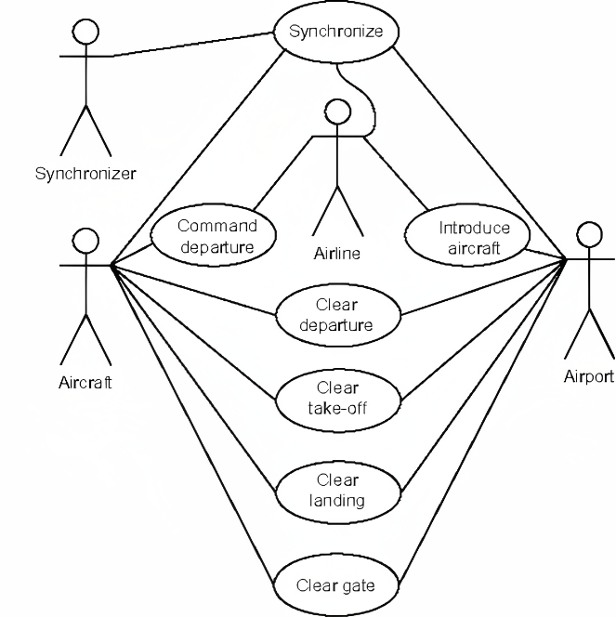

Figure1: Use case diagram of flight information display system

Next, the diagram illustrates how the system displays the flight information to passengers. This can be through digital displays, mobile apps, or any other medium used within the FIDS. If the system supports personalized updates, the diagram may show how it determines the relevant information for each passenger based on their preferences and travel itinerary. Throughout the diagram, there may be decision points that depend on certain conditions. For example, if there are multiple gate options available for a flight, the system may need to select the most suitable gate based on factors like aircraft size, availability, and airline preferences. Finally, the diagram concludes with an end state, representing the completion of the activities. This can occur once all flight information has been displayed and any necessary updates have been made.

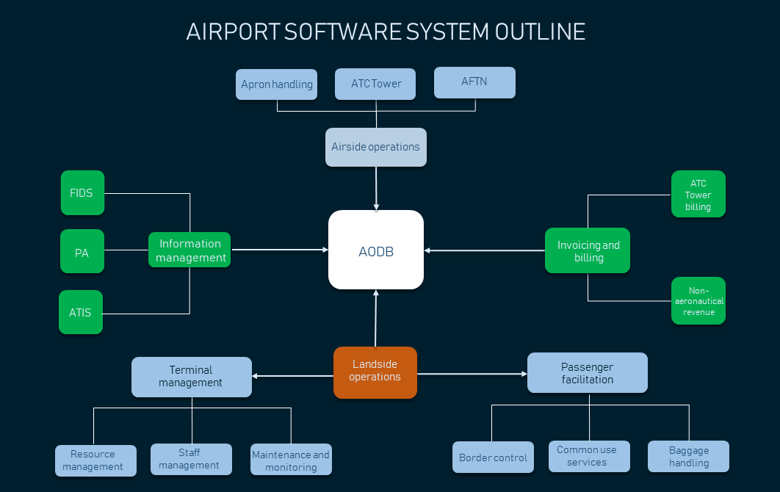

Figure 2: Flow diagram representation different stages of flight information display system

# Implementation Methodology

Designing a good Flight Information Display System (FIDS) is essential to ensure that passengers and airport staff receive accurate and up-to-date information. Here are the basic steps to take care of when designing such a system.

**Understand User Needs**: Identify the various user groups, such as passengers, airline staff, airport personnel, and flight crews, and determine their specific information requirements.

**Gather Requirements**: Collaborate with stakeholders to gather detailed requirements for the FIDS, including the types of information to be displayed, the locations of displays, and any regulatory or accessibility requirements.

**User Interface Design**: Design a user-friendly interface that provides clear and concise information. Consider factors such as font size, colours, and layout for readability and accessibility.

**Data Sources and Integration**: Establish connections with data sources, such as airlines, air traffic control, and weather services, to ensure real-time and accurate information. Implement robust integration protocols for data retrieval.

**Data Accuracy and Redundancy**: Implement measures to ensure data accuracy and redundancy. Information should be updated in real-time and backed up to prevent downtime.

**Network Infrastructure**: Ensure a robust and reliable network infrastructure to support data transfer and real-time updates to the displays.

**Emergency Information**: Include provisions for displaying emergency information and alerts. This can include weather warnings, security updates, and evacuation instructions.

**Wayfinding and Signage**: Integrate the FIDS with the airport's wayfinding and signage system to guide passengers to their destinations.

**Accessibility**: Ensure compliance with accessibility standards, including options for visually impaired passengers through text-to-speech functionality and clear visual displays for the hearing impaired.

**Testing and Quality Assurance**: Rigorously test the system to ensure it functions correctly under various conditions, including high traffic periods and emergencies.

**Security Measures**: Implement security measures to protect the system from cyber threats and unauthorized access.

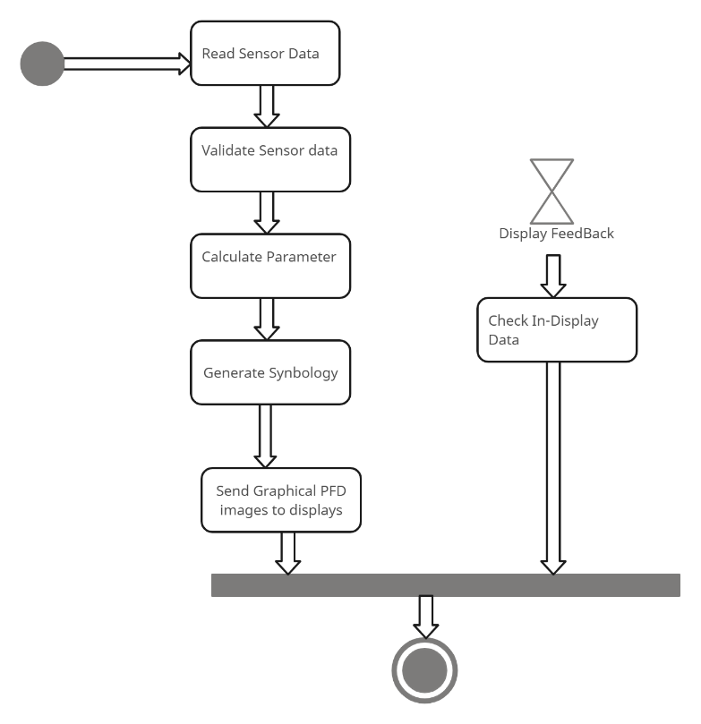

**Figure 3:** Activity diagram of flight information display system

An activity diagram is a visual representation of the flow of activities within a system. In the case of the Flight Information Display System (FIDS), an activity diagram can help illustrate the various steps and interactions involved in displaying flight information to passengers. The diagram typically starts with an initial state, representing the system being in an idle state, waiting for input. The first activity is often triggered by an event, such as a flight schedule update or a passenger request for information. From there, the diagram depicts a series of actions and decisions. For example, the system may need to retrieve updated flight data from a database or an external source. This data can include information such as flight numbers, departure times, arrival times, gate assignments, and any delays or cancellations. Once, the relevant flight information is obtained, the diagram may show how the system processes and organizes this data. This can involve sorting flights by departure time, grouping them by destination, or any other logical organization method.

# Result & Conclusion

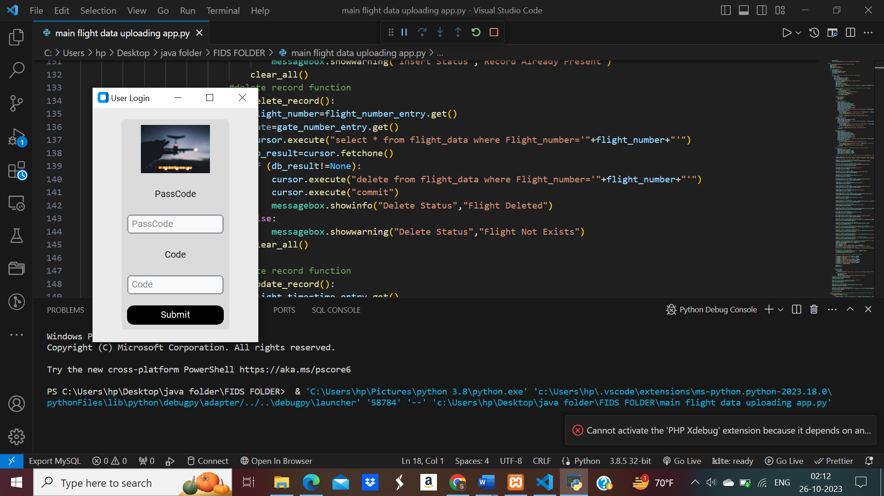

Figure 4: User details validation software with passcode insertion

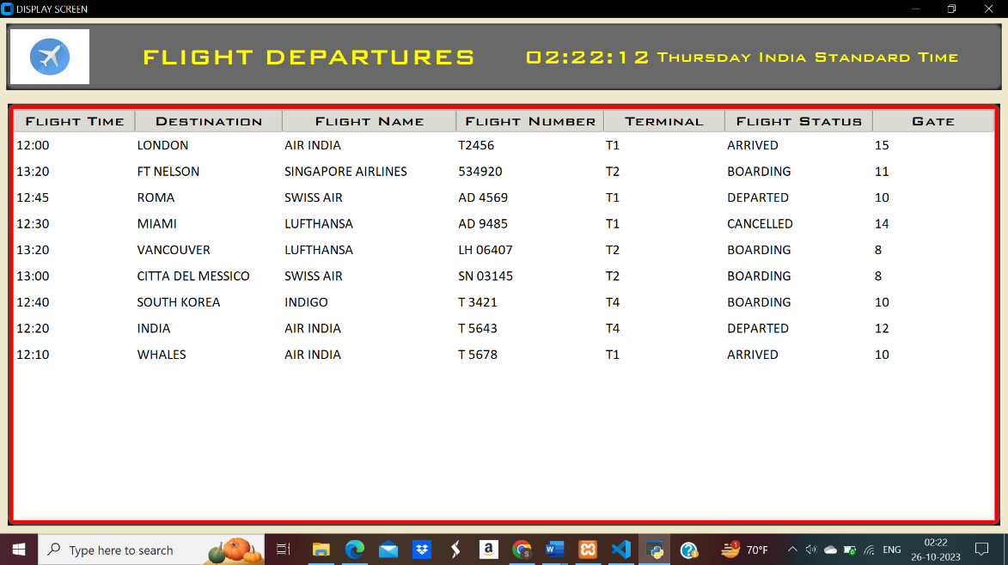

Figure 5: Display board representing the flight details with their flight departures

# Future Scope and further enhancement of the Project

Main future scope of this model is to generate the required result on time with proper accuracy and enhanced security. Secondly, the main purpose of this software is to deal with the database records in order to present them in the database. In the third most important process its necessary to deal with the security measures on time in order to prevent the unwanted access to the database and its records. IOT Integration, customization and personalization.

# Advantages of this Project

The Flight Information Display System (FIDS) plays a pivotal role in the smooth and efficient functioning of airports, serving as the primary interface for passengers and airport personnel to access critical flight information. However, this essential system is not without its challenges. The contemporary aviation landscape demands a high degree of data accuracy, security, and integration, as airports continue to grow in size and complexity. Redundancy and resilience are critical to maintaining operational continuity in the face of system failures. The user experience, accessibility, and multilingual support have become paramount, given the diverse passenger base of global airports. Furthermore, the need for real-time updates, adaptation to new technologies, and compliance with ever-evolving regulations all present ongoing hurdles. The cost implications and sustainability concerns cannot be ignored, as airports strive to balance providing accurate information with financial prudence and eco-consciousness. In light of these challenges, FIDS providers and airport operators must remain committed to innovation, continuous improvement, and collaboration with relevant stakeholders to ensure that FIDS continues to meet the dynamic needs of the aviation industry while enhancing the passenger experience and maintaining a secure, reliable, and environmentally responsible presence in airports worldwide.

# Outcome

Project to product

# References

*[1] S. Moran and K. Nakata , “A Distributed Cognition Based Tool for Information Trajectory Analysis ,” in ACM International Conferences on Web Intelligence and Intelligent Agent Technology, IEEE, Oct. 2011.*

*[2] S. Shao, M. Chen, and Y. Zhang, “Adaptive Discrete-Time Flight Control Using Disturbance Observer and Neural Networks,” IEEE transactions on neural networks and learning systems, vol. 30, no. 12, pp. 3708–3721, Dec. 2019, doi: https://doi.org/10.1109/tnnls.2019.2893643.*

*[3] K. A. Klein, H. Eckberg, and R. H. Dean, “An analysis of low-cost simulated flight management systems for aviation research,” Oct. 2009, doi: https://doi.org/10.1109/dasc.2009.5347569.*

*[4] Ngoc Phu Tran, D.-T. Pham, Sim Kuan Goh, S. Alam, and V. Duong, “An Intelligent Interactive Conflict Solver Incorporating Air Traffic Controllers’ Preferences Using Reinforcement Learning,” 2019 Integrated Communications, Navigation and Surveillance Conference (ICNS), Apr. 2019, doi: https://doi.org/10.1109/icnsurv.2019.8735168.*

*[5] A. Burns, D. Harper, A. F. Barfield, S. Whitcomb, and B. Jurusik, “Auto GCAS for analog flight control system,” 2011 IEEE/AIAA 30th Digital Avionics Systems Conference, Oct. 2011, doi: https://doi.org/10.1109/dasc.2011.6096148.*

[6] R. A. Nichols, R. T. Reichert, and W. J. Rugh, “Gain scheduling for H-infinity controllers: a flight control example,” IEEE Transactions on Control Systems Technology, vol. 1, no. 2, pp. 69–79, Jun. 1993, doi: https://doi.org/10.1109/87.238400.

*[7] M. Kaptsov and L. Rodrigues, “Flight management systems for all-electric aircraft,” IEEE Xplore, Aug. 01, 2017. https://ieeexplore.ieee.org/abstract/document/8062767 (accessed Mar. 12, 2023).*

*[8] S. C. Jensen, G. D. Jenney, and D. M. Dawson, “Flight test experience with an electromechanical actuator on the F-18 Systems Research Aircraft,” Document Analysis Systems, Jan. 2000, doi: https://doi.org/10.1109/dasc.2000.886914.*

*[9] X. Yin, K. Xu, H. Liang, G. Zhang, X. Peng, and Q. Zhang, “Hardware Design of Flight Control System and Flight Experiments of Small-Scale Unmanned Aerial Vehicle,” IEEE Conference Paper, Aug. 2020, doi: https://doi.org/10.1109/ccdc49329.2020.9164578.*

*[10] M. Karpenko and N. Sepehri, “Hardware-in-the-loop simulator for research on fault tolerant control of electrohydraulic actuators in a flight control application,” Mechatronics, vol. 19, no. 7, pp. 1067–1077, Oct. 2009, doi: https://doi.org/10.1016/j.mechatronics.2009.01.008.*

*[11] Phạm Minh Đức et al., “HoanKiemAir: simulating impacts of urban management practices on traffic and air pollution using a tangible agent-based model,” HAL (Le Centre pour la Communication Scientifique Directe), Oct. 2020, doi: https://doi.org/10.1109/rivf48685.2020.9140787.*

*[12] R. de, F. Carvalho, J. Batista Camargo, and Liria Matsumoto Sato, “Multi-Agent Tools for Air Traffic Management,” Computational Science and Engineering, Jul. 2008, doi: https://doi.org/10.1109/csew.2008.46.*

*[13] M. Bodson and J. E. Groszkiewicz, “Multivariable adaptive algorithms for reconfigurable flight control,” IEEE Transactions on Control Systems Technology, vol. 5, no. 2, pp. 217–229, Mar. 1997, doi: https://doi.org/10.1109/87.556026.*

*[14] G. Campa, Mario Luca Fravolini, M. Napolitano, and B. Seanor, “Neural networks-based sensor validation for the flight control system of a B777 research model,” Jun. 2003, doi: https://doi.org/10.1109/acc.2002.1024840.*

*[15] Fang Liao, Jian Liang Wang, and Guang-Hong Yang, “Reliable robust flight tracking control: an LMI approach,” IEEE Transactions on Control Systems Technology, vol. 10, no. 1, pp. 76–89, 2002, doi: https://doi.org/10.1109/87.974340.*

*[16] Z. Song, “Research and Implementation of Simulation System for Flight Multi-Function Display,” Computer Simulation, Jan. 2004.*

*[17] P. Lu, Laurens Van Eykeren, E. van Kampen, Coen, and Q. P. Chu, “Aircraft Inertial Measurement Unit Fault Identification with Application to Real Flight Data,” IEEE conference , vol. 38, no. 12, pp. 2467–2475, Dec. 2015, doi: https://doi.org/10.2514/1.g001247.*

*[18] Ayad Al-Mahturi, F. Santoso, M. Garratt, and S. G. Anavatti, “Self-Learning in Aerial Robotics Using Type-2 Fuzzy Systems: Case Study in Hovering Quadrotor Flight Control,” Scopus, vol. 9, pp. 119520–119532, Jan. 2021, doi: https://doi.org/10.1109/access.2021.3107906.*

*[19] G. Silano, P. Oppido, and L. Iannelli, “Software-in-the-loop simulation for improving flight control system design: a quadrotor case study,” IEEE Confernce paper , Oct. 2019, doi: https://doi.org/10.1109/smc.2019.8914154.*

*[20] E. Crück and J. Lygeros, “Subliminal air traffic control: Human friendly control of a multi-agent system,” Proceedings of the ... American Control Conference, Jul. 2007, doi: https://doi.org/10.1109/acc.2007.4282641.*

*[21] C. H. Acton, “Ancillary data services of NASA’s Navigation and Ancillary Information Facility,” Planetary and Space Science, vol. 44, no. 1, pp. 65–70, Jan. 1996, doi: https://doi.org/10.1016/0032-0633(95)00107-7.*

*[22] H. Yao, “The Realization of Flight Simulation System Based on OpenGL,” IEEE paper , Jul. 2010, doi: https://doi.org/10.1109/itcs.2010.55.*

*[23] Wolfgang Kubbat, Peter Marcus Lenhart, and Harro von Viebahn, “4D flight guidance displays, a gate to gate solution,” Nov. 2002, doi: https://doi.org/10.1109/dasc.1998.741594.*

*[24] S. Mao, Z. Ren, and J. Zhao, “An off-axis flight vision display system design using machine learning,” IEEE Photonics Journal, vol. 14, no. 2, pp. 1–6, Apr. 2022, doi: https://doi.org/10.1109/jphot.2022.3155250.*

*[25] J. L. Garloch, “Flight testing of a prototype Cockpit Display of Traffic Information for approach spacing applications,” Nov. 2002, doi: https://doi.org/10.1109/dasc.2001.963387.*

[26] C. W. Reynolds, “Flocks, herds and schools: A distributed behavioral model,” ACM SIGGRAPH Computer Graphics, vol. 21, no. 4, pp. 25–34, Aug. 1987, doi: https://doi.org/10.1145/37402.37406.

*[27] C. A. Wargo, G. C. Church, J. Glaneueski, and M. Strout, “Unmanned Aircraft Systems (UAS) research and future analysis,” IEEE Xplore, Mar. 01, 2014. https://ieeexplore.ieee.org/abstract/document/6836448/citations?tabFilter=papers#citations (accessed May 02, 2022).*

*[28] J. E. Prussing, “Geometrical Interpretation of the Angles CY and B in Lambert’s Problem,” Journal of guidance and control, vol. 2, no. 5, pp. 442–443, Sep. 1979, doi: https://doi.org/10.2514/3.55905.*

[29] I. Flight, Flight Test Instrumentation; Proceedings. 1965.

*[30] “Flight Journal - Aviation History | History of Flight | Aviation History Articles, Warbirds, Bombers, Trainers, Pilots,” Flight Journal. https://www.flightjournal.com/*